“Frozen” Python programs can be run on computers without installing a full version of Python. If the frozen version of the program has been created with PyInstaller, the source code folder will have a “dist” folder. For example:
- The folder “Stain Selection FROZEN – INSTR-Rev 2” has the source code for the Python program “stain_selection_gui.py” and has the folder “dist”
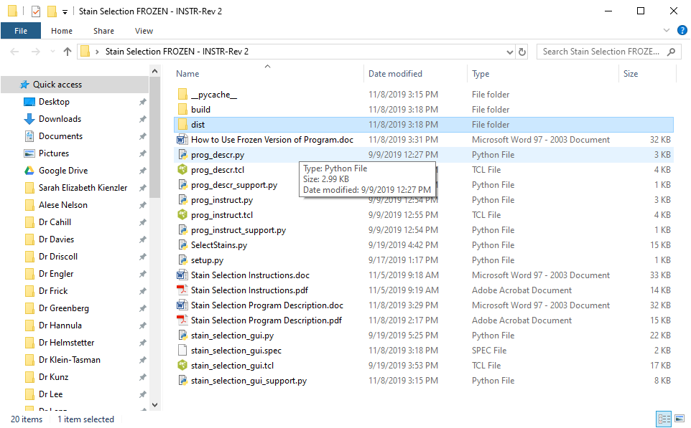
- The “dist” folder contains a folder “stain_selection_gui”, the same name as the frozen source code program. Copy this folder to the target computer.
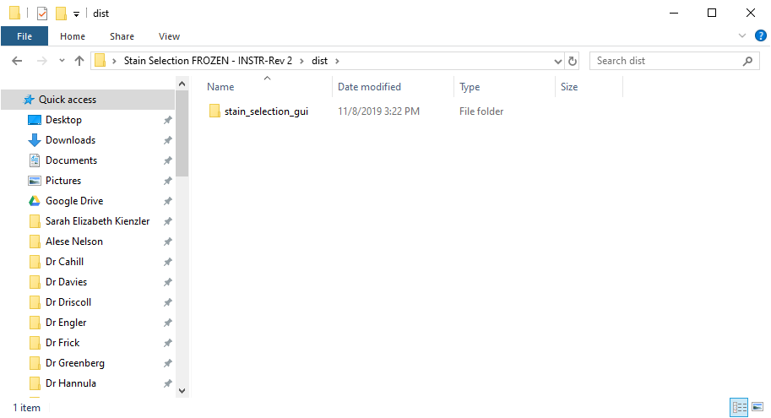
- Open the folder on the target computer. Launch the program by double clicking on the “exe” file, in this example “stain_selection_gui.exe”.
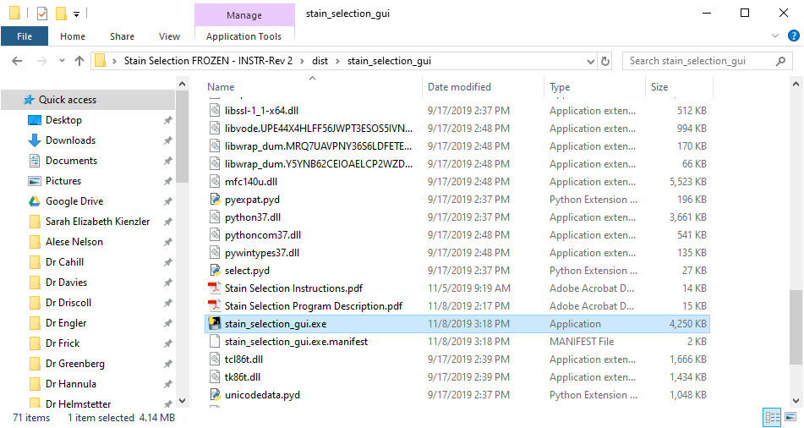

One may also create a shotcut and place it on the desktop etc. The shortcut may be given a unique name as long as it points to the original executable file.

